

MATHEMATICS DEPARTMENT |  | 
Course: ATMAA
Topic Title: Skills Test 5
Student Name:_____________________________________ | Date: __________2016
Special Instructions: Calculator Free | Time Allowed: 20 mins
 | Marks: / 14
Question 1 (1 mark)
How many vertices are there in the graph below?
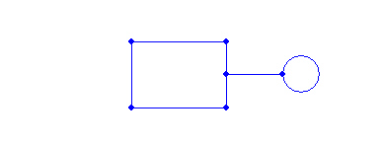
A | 5 B 6 | C | 7 D 8 | E | 9

Question 2 (1 mark)
How many edges are directly connected to point D?
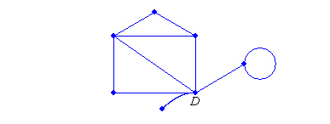
A | 1 B 2 | C | 3 D 4 | E | 5

Question 3 (1 mark)
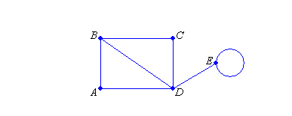
Which point(s) are adjacent to point C?

A E B B, D C A, B, D D B, D, E E No points adjacent to point C

Question 4 (1 mark)
Which of the following is a simple graph?
A B C
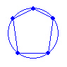
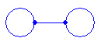
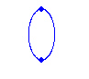

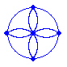
D E
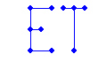

Question 5 (1 mark)
Which of the following is a bipartite graph?

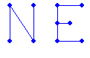
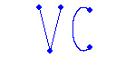
A B C
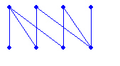

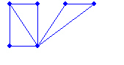
D E
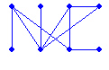

Question 6 (1 mark)
How many edges would a complete graph have if it contained 11 vertices?

A 55 B 66 C 110 D 121 E 132

Question 7 (1 mark)
The following graph diagram represents tennis games which were played over one day. Which opponent(s) did person A play?
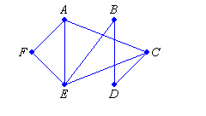

A E, F B B, F C B, E, F D C, E, F E C, D, E, F

Question 8 (1 mark)

Show two routes that Helen can use to get from E to C, using the one-way streets as marked, and not returning to E on the way.

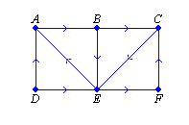

A E-C and E-B-C B E-C and E-F-C C E-C and E-A-B-C

D E-B-C and E-F-C E E-F-C and E-A-B-C

Question 9 (1 mark)

Represent the following graph using an adjacency matrix. Both rows and columns should be in the order A to F, from left to right and from top to bottom.

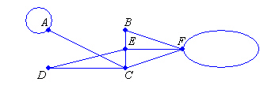

A B C D E
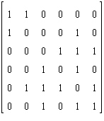
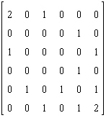
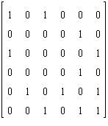
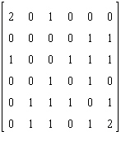
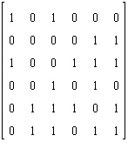

Question 10 (1 mark)
A planar graph has 7 vertices and 9 edges. How many faces must it have?

A 2 B 3 C 4 D 5 E 6

Question 11 (1 mark)

Which of the following is an Eulerian graph?

A B C D E

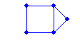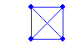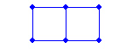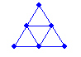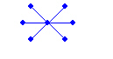

Question 12 (1 mark)

Which of the following is a semi-Eulerian graph?

A B C D E
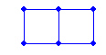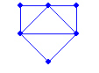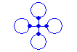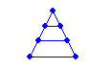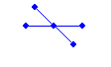

Question 13 (1 mark)

Calculate the degree of vertex P.

A 1 B 2 C 3 D 4 E 5

Question 14 (1 mark)


Calculate the degree sum of the graph below.

A 7 B 8 C 14 D 15 E 16

